|  |  |  |
| --- | --- | --- |
|  | Functional Requirements Document (FRD) for:  [Project Name] | |
| Job #: |  |
| Project Sponsor: |  |
| Business Owner / Product Manager: |  |
| Business Analyst: |  |
| Project Manager: |  |

# REQUIREMENTS: SIGN-OFF AND APPROVAL

|  |  |  |  |  |
| --- | --- | --- | --- | --- |
|  | | | | |
|  |  |  |  |  |
| *Business Analyst* |  | *Signature* |  | *Date* |
|  |  |  |  |  |
| *Sr. Manager, IT Process Improvement* |  | *Signature* |  | *Date* |
|  |  |  |  |  |
| *Business Owner/Product Manager* |  | *Signature* |  | *Date* |
|  |  |  |  |  |
| *Director, Marketing* |  | *Signature* |  | *Date* |
|  |  |  |  |  |
| *Director, IT Systems Development or Delegate* |  | *Signature* |  | *Date* |
|  |  |  |  |  |
| *Project Manager* |  | *Signature* |  | *Date* |
|  |  |  |  |  |
| *Business Development Manager* |  | *Signature* |  | *Date* |
|  |  |  |  |  |
| *Sr. Director, Online Marketing* |  | *Signature* |  | *Date* |
|  |  |  |  |  |
| *Sr. Manager, Promotions* |  | *Signature* |  | *Date* |

# CREATIVE: SIGN-OFF AND APPROVAL

Sign-off after creative elements (i.e. wireframes, website design, etc.) have been produced based on the completed requirements. Identify the creative elements produced below and attach a copy to this document when routing for approvals.

Wireframes

Website design

[Other Creative Elements]

|  |  |  |  |  |
| --- | --- | --- | --- | --- |
|  | | | | |
|  |  |  |  |  |
| *Business Analyst* |  | *Signature* |  | *Date* |
|  |  |  |  |  |
| *Sr. Manager, IT Process Improvement* |  | *Signature* |  | *Date* |
|  |  |  |  |  |
| *Business Owner/Product Manager* |  | *Signature* |  | *Date* |
|  |  |  |  |  |
| *Director, Marketing* |  | *Signature* |  | *Date* |
|  |  |  |  |  |
| *Director, IT Systems Development or Delegate* |  | *Signature* |  | *Date* |
|  |  |  |  |  |
| *Project Manager* |  | *Signature* |  | *Date* |
|  |  |  |  |  |
| *Business Development Manager* |  | *Signature* |  | *Date* |
|  |  |  |  |  |
| *Sr. Director, Online Marketing* |  | *Signature* |  | *Date* |
|  |  |  |  |  |
| *Sr. Manager, Promotions* |  | *Signature* |  | *Date* |

# CHANGE LOG

|  |  |  |  |
| --- | --- | --- | --- |
| Version # | Date | CR # | Description of Change |
|  |  |  |  |
|  |  |  |  |
|  |  |  |  |
|  |  |  |  |
|  |  |  |  |

1 REQUIREMENTS: SIGN-OFF AND APPROVAL 2

2 CREATIVE: SIGN-OFF AND APPROVAL 2

3 CHANGE LOG 3

4 BACKGROUND INFORMATION 5

4.1 Current Environment 5

5 ASSUMPTIONS 5

6 SUMMARY OF SYSTEMS/APPLICATIONS IMPACT 5

7 Send Automated Emails 6

7.1 Business Rules 6

7.2 Functional Requirements 6

8 <Airlines Name> Air.com: ‘<Airlines Name> Miles’ Page Updates 8

8.1 Screen Mock-Up 8

8.2 Functional Requirements 8

9 Add ‘Vegas Club’ Page 9

9.1 Screen Mock Up 9

9.2 Business Rules 10

9.3 Functional Requirements 10

10 Add ‘Sweepstakes Enrollment’ Page 12

10.1 Screen Mock Up 12

10.2 Business Rules 12

10.3 Functional Requirements 12

# BACKGROUND INFORMATION

## Current Environment

<Airlines Name> Airlines, Inc is a largest carrier serving the local <Airlines Name> market that travels to Las Vegas.

# ASSUMPTIONS

* The member portal content file will look for Vegas file. (This will only show up if it exists)
* Will have single generic content for <Airlines Name>Miles portal and Member Portal.

# SUMMARY OF SYSTEMS/APPLICATIONS IMPACT

Select the systems/applications that would be impacted due to this project and/or that need to be thoroughly tested during the execution of this project.

|  |  |  |  |  |  |  |
| --- | --- | --- | --- | --- | --- | --- |
| System/Application | Project Impact | | Testing Impact | | Business Owner | Application Owner |
| Share point | Yes | No | Yes | No |  |  |
| <Airlines Name>Miles | Yes | No | Yes | No |  |  |
| *Vegas Club Partner offers | Yes | No | Yes | No |  |  |

# Send Automated Emails

## Business Rules

| Req. ID | Description | Business Owner |
| --- | --- | --- |
|  | **Initial ‘Las Vegas Club Profile’ Eligibility**  A member who meets all the following criteria is an eligible member for initial ‘Las Vegas Club” profile creation at the time of the release of this feature:   * Must be a member of <Airlines Name> Miles * Must have purchased a ticket from any city in North America to Vegas via any payment source other than using <Airlines Name>Miles over the past 18 months * Must be a resident of Hawaii |  |
|  | **Ongoing ‘Las Vegas Profile Creation’**  After the release date on an ongoing basis, a member who meets all the following criteria is eligible for ‘Las Vegas Club’ profile creation:   * Must be a member of <Airlines Name> Miles * Must have purchased a ticket from any city of North America to Vegas via any payment source other than using <Airlines Name>Miles over the past 12 months |  |
|  | **Remove ‘Las Vegas Club’ Profile**  ‘Las Vegas Club’ Profile applied in the <Airlines Name>Miles DB for a respective member shall be removed in the following 2 events:   * Remove the profile on June 30 of the year following the member’s profile was created and the member not flying to Las Vegas from since the member profile was created. * Remove the profile on June 30 of the year following the member’s profile was created and the member flying to Las Vegas but not purchasing Las Vegas ticket via any payment source other than using <Airlines Name>Miles from the date of applying the ‘Las Vegas Club’ profile . |  |

## Functional Requirements

| Req. ID | Requirement | System/Application Impacted |
| --- | --- | --- |
|  | **Create ‘Las Vegas Club Profile’**  System shall create ‘Las Vegas Club Profile’ and automatically apply the profile in the <Airlines Name>Miles DB for all the members that meets the following criteria:   * Must be a member of <Airlines Name> Miles * Must have purchased Las Vegas ticket via any payment source other than using <Airlines Name>Miles over the past 12 months | Backend |
|  | **Send First Automated Email**  On the day of the release of this feature, system shall send an automated email to every member of the ‘Las Vegas Club Profile’ notifying them of the availability of Las Vegas Club Deals feature. | Backend |
|  | **Ongoing Email Automation**  After the release of the feature, system shall automatically send the Las Vegas Club Deals promotion email to the respective user as and when the user meets the respective criteria | Backend |
|  | **Email Hyperlink Navigation**  When the user clicks ‘Partner Offer’ hyperlink in the Las Vegas Deals Promotional email, system shall navigate the user to ‘Vegas Club’ page. | <Airlines Name> Member Email Inbox |

# <Airlines Name> Air.com: ‘<Airlines Name> Miles’ Page Updates

## Screen Mock-Up

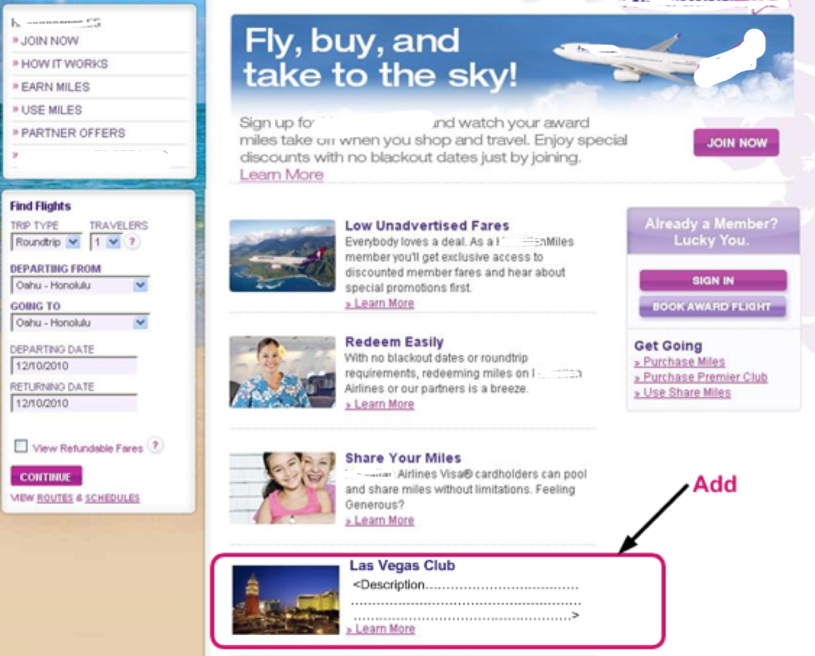

## Functional Requirements

| Req. ID | Requirement | System/Application Impacted |
| --- | --- | --- |
|  | **‘Las Vegas Club’ Creative Detail**  System shall display ‘Las Vegas Club’ creative ,under the ‘Share Your Miles’ creative, displaying the following:  Creative Image:  Creative Name: Las Vegas Club  Creative Description: <Need to Add Description>  Hyperlink Name: **Learn More** | <Airlines Name>air.com |
|  | **Las Vegas Club Creative: ‘Learn More’ Hyperlink Navigation**  When the user clicks ‘Learn More’ hyperlink displayed in the ‘Las Vegas Club’ creative, system shall navigate the user to the ‘Vegas Club’ page | <Airlines Name>air.com |

# Add ‘Vegas Club’ Page

## Screen Mock Up

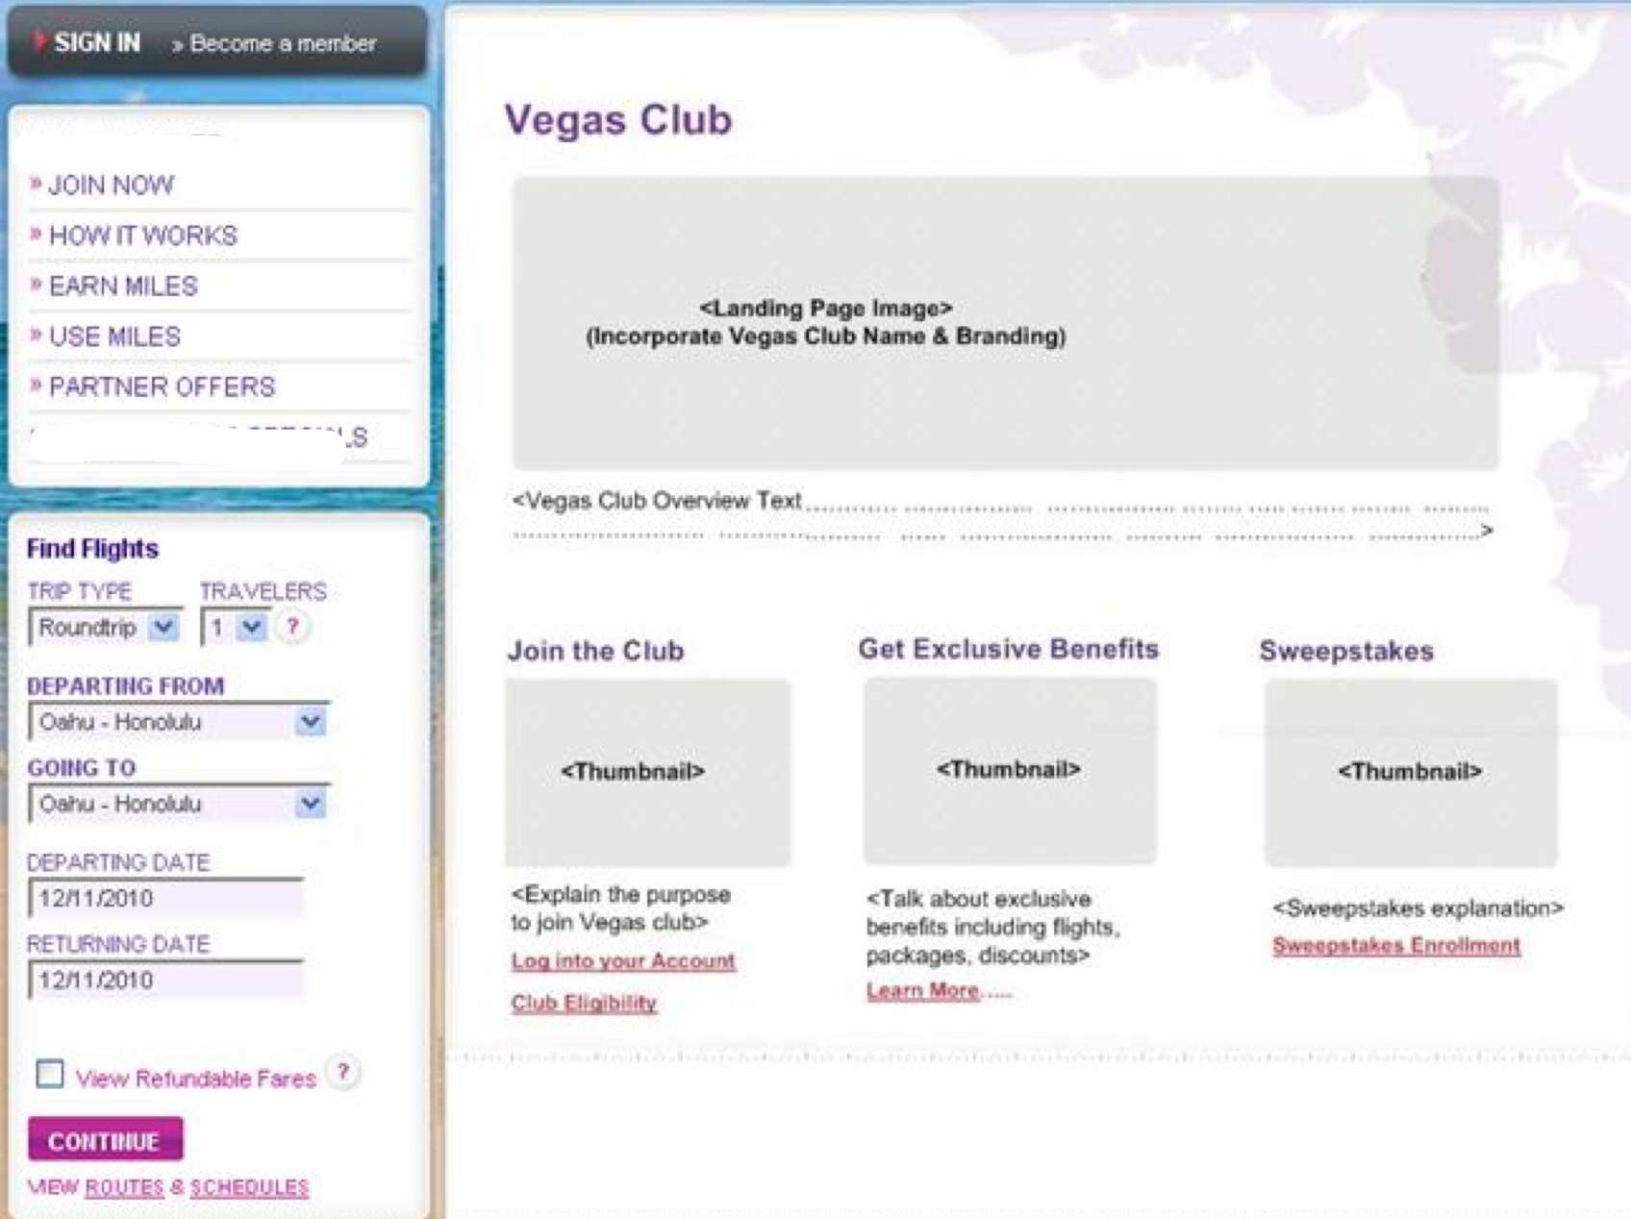

## Business Rules

| Req. ID | Description | Business Owner |
| --- | --- | --- |
|  | **None** |  |

## Functional Requirements

| Req. ID | Requirement | System/Application Impacted |
| --- | --- | --- |
|  | **Navigation to ‘Vegas Club’ Page**  System shall navigate the user to the ‘Vegas Club’ in either of the following 2 scenarios:   * <Airlines Name> miles member clicking the ‘Partner Offer’ hyperlink from the ‘Las Vegas Club’ promotion email * User clicking ‘Learn More’ hyperlink displayed in ‘Las Vegas Club’ creative on ‘<Airlines Name> Miles’ page | <Airlines Name>air.com |
|  | **‘Vegas Club’ Page Creative Details**  System shall display the following creative’s on ‘Vegas Club’ page:   |  |  |  |  | | --- | --- | --- | --- | | **Creative**  **Name** | **Creative Image** | **Creative Description** | **Hyperlink Displayed Name** | | Vegas Club |  | TBD |  | | Join The Club |  | TBD | Log into your account | | Club Eligibility | | Get Exclusive Benefits |  | TBD | Learn More | | Sweepstakes |  | TBD | Sweepstakes Enrollment | | <Airlines Name>air.com |
|  | **‘Join The Club’ Creative: “Log into your account” Hyperlink Navigation**  When the user clicks “Log into your account” hyperlink displayed under ‘Join The Club’ creative, system shall navigate the user based on the following logic:   * Navigate the user to <Airlines Name>Miles login page in the event of the user is not signed in * Navigate the user to ‘terms & conditions’ page in the event of the user being signed in but the user has not accepted ‘terms & conditions’ * Navigate the user to ‘Member Deals’ page in the event of the user being signed in and the user has accepted ‘terms & conditions’ | <Airlines Name>air.com |
|  | **‘Join The Club’ Creative: “How to Qualify” Hyperlink Navigation**  This requirement will be coming from promotion team and swift | <Airlines Name>air.com |
|  | **‘Get Exclusive Benefits’ Creative: “Learn More” Hyperlink Navigation**  When the user clicks “Learn More” hyperlink displayed under ‘Join The Club’ Creative, system shall navigate the user based on the following logic:   * Navigate the user to <Airlines Name>Miles login page in the event of the user is not signed in * Navigate the user to ‘terms & conditions’ page in the event of the user being signed in but the user has not accepted ‘terms & conditions’   Navigate the user to ‘Member Deals’ page in the event of the user being signed in and the user has accepted ‘terms & conditions’ | <Airlines Name>air.com |
|  | **‘Sweepstakes’ Creative: “Sweepstakes Enrollment” Hyperlink Navigation**  When the user clicks “Sweepstakes Enrollment” hyperlink displayed under ‘Sweepstakes’ creative, system shall navigate the user to sweepstakes enrollment page | <Airlines Name>air.com |

# Add ‘Sweepstakes Enrollment’ Page

## Screen Mock Up

## Business Rules

| Req. ID | Description | Business Owner |
| --- | --- | --- |
| BR.4 | **Sweepstakes Enrollment Eligibility**  Only <Airlines Name>Miles member are eligible for sweepstakes enrollment |  |

## Functional Requirements

| Req. ID | Requirement | System/Application Impacted |
| --- | --- | --- |
|  | **Navigation to ‘Sweepstakes Enrollment’ Page**  System shall navigate the user to ‘Sweepstakes Enrollment’ page in the event of the user clicking ‘Sweepstakes Enrollment’ hyperlink displayed under ‘Sweepstakes’ creative on ‘Vegas Club’ page | <Airlines Name>air.com |
|  | **‘Sweepstakes Enrollment’ Page Data Fields**  System shall display the following data fields on ‘Sweepstakes Enrollment’ Page:   |  |  |  |  |  | | --- | --- | --- | --- | --- | | **Field Name** | **Field Type** | **Data Entry Format** | **Content** | **Required?** | | <Airlines Name>Miles Number | Text Box | ### ### ### | Numeric | Yes | | First Name | Text Box | n/a | Alpha Numeric | Yes | | Last Name | Text Box | n/a | Alpha Numeric | Yes | | Email Address | Text Box | youremail@domain.com | Alpha Numeric | Yes | | Phone Number | Text Box | (###)###-#### | Numeric | Yes | | Agree to Terms & Conditions | Check Box | n/a | Agree | Yes | | Submit | Command  Button | n/a | n/a | n/a | | <Airlines Name>air.com |
|  | **Sweepstakes Enrollment Validation**  When the user clicks ‘Submit’ command button after entering data fields on ‘Sweepstakes Enrollment’ page, system shall conduct the following validation:   1. Validate that all mandatory data fields have been entered 2. Validate the correct data entry format | <Airlines Name>air.com |
|  | **Successful Sweepstakes Enrollment**  System shall notify the user of the successful sweepstakes enrollment in the event of successful sweepstakes enrollment and navigate the user to ‘Vegas Club’ page. | <Airlines Name>air.com |
|  | **Sweepstakes Enrollment Error Notification**  System shall display the following error messages in the event of the following error scenarios:   |  | | --- | | **Error Scenario** | | Invalid <Airlines Name>Miles Number | | Respective <Airlines Name>Miles Number is already enrolled in Sweepstakes | | Invalid <Airlines Name>Miles Number format | | <Airlines Name>Miles Number not entered | | First Name not entered | | Last Name not entered | | Invalid Email Address Formal | | Email Address not entered | | Invalid Phone Number format | | Phone Number not entered | | Terms & Conditions Check Box not checked | | Invalid <Airlines Name>Miles Number- First Name- Last Name combination | | <Airlines Name>air.com |